1. **The Test suite automatically runs on a regular basis. (Once per day)**

**Here, I have specified the time to run the test suite at “2.20PM” everyday**

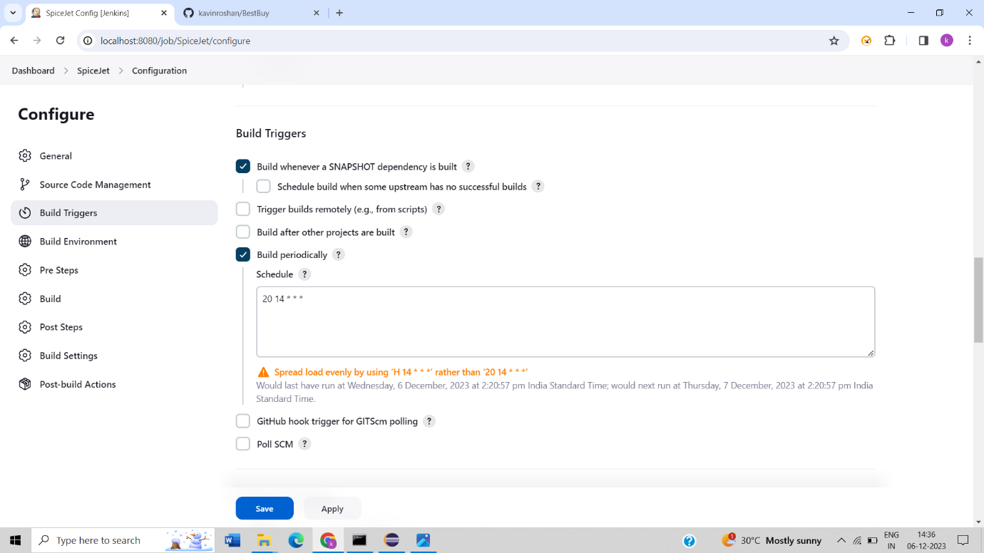

1. **Success Console Output – Jenkins**

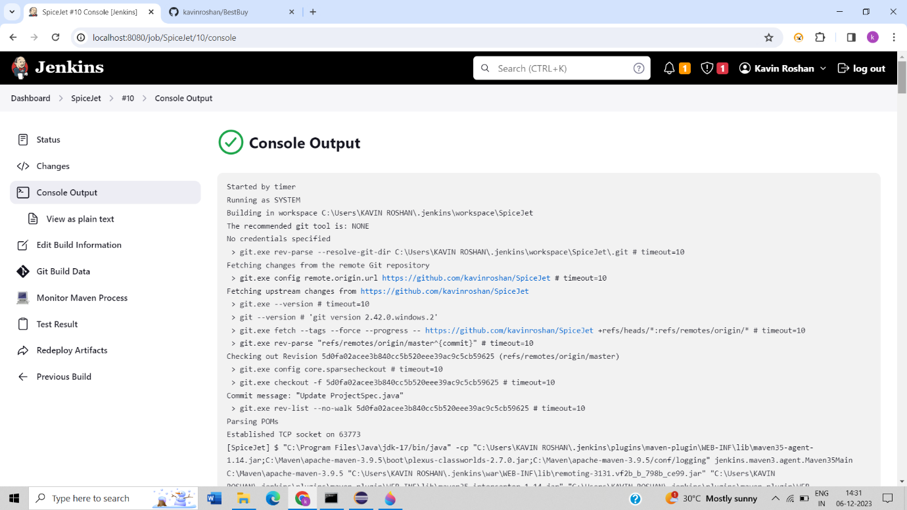

1. **Total tests run details**

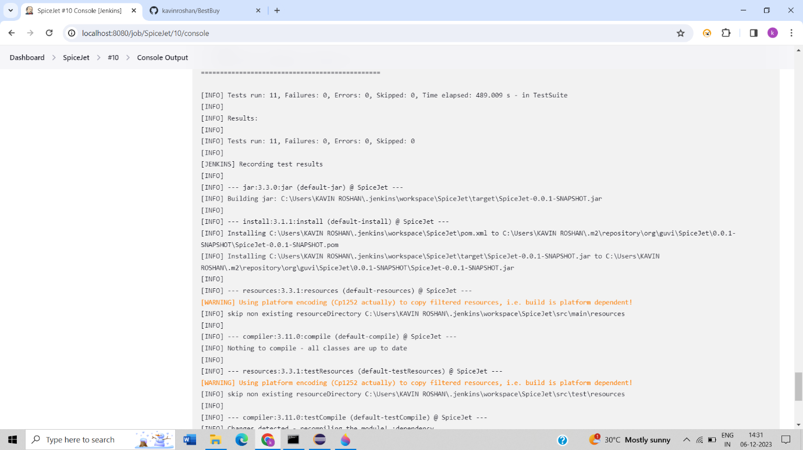

1. 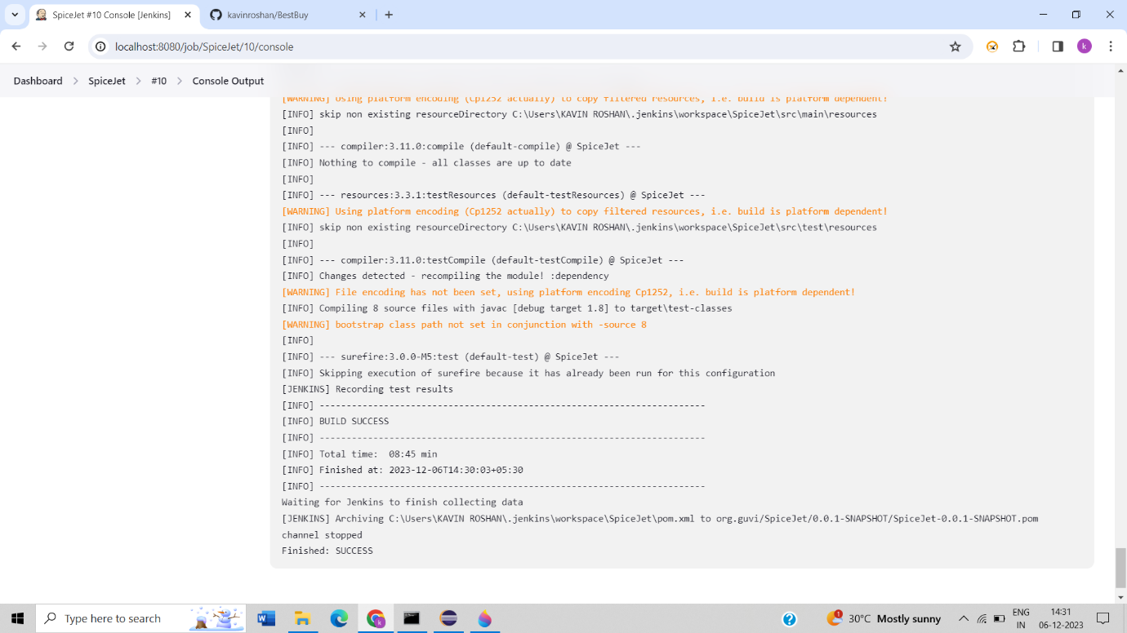**Finished status - Success**